Project Report
Library Management System
Name: Aditi Anil Kandhare
Project Title: Library Management System
Date of Submission: 29-01-2026
Technology used: Language (Python)

Introduction
The Library Management System is a simple Python-based project designed to manage book records efficiently.It helps in performing basic library operations such as adding, viewing, searching, editing, and deleting books. The system uses Object-Oriented Programming (OOP) concepts to organize book details properly. All book information is stored permanently in a text file using file handling. This project reduces manual work and provides an easy menu-driven interface for users. It is a beginner-friendly application that demonstrates real-life use of Python programming.
Aim of the Project
The Library Management System is a simple Python application used to manage book details in a library. It allows users to add, view, search, edit, and delete book records easily.
All book information is stored in a text file, making the data available even after the program ends. This project is useful for understanding basic file handling and object-oriented programming in Python.
Objectives
To create a basic library system using Python.
To understand the concepts of OOP (Object-Oriented Programming).
To implement File Handling for storing and retrieving book records.
To provide a menu-driven program for easy user interaction.
Working Procedure
This project is developed using Python and follows an object-oriented approach.
Book details are stored using a Book class, and all library operations are managed through a Library class. The system uses file handling to save and load book records from a text file.
A menu-driven program allows users to easily add, view, search, edit, and delete books.
- Add Book

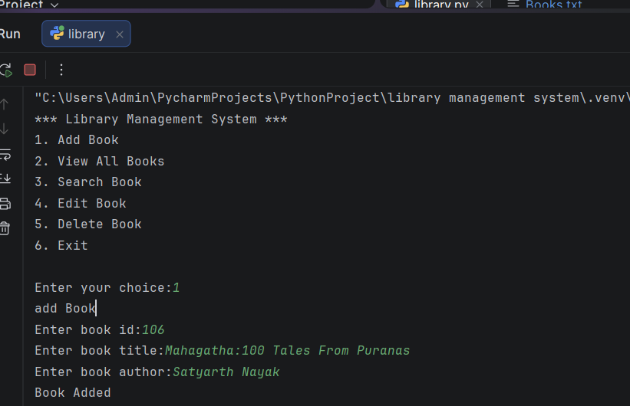
- View All Books
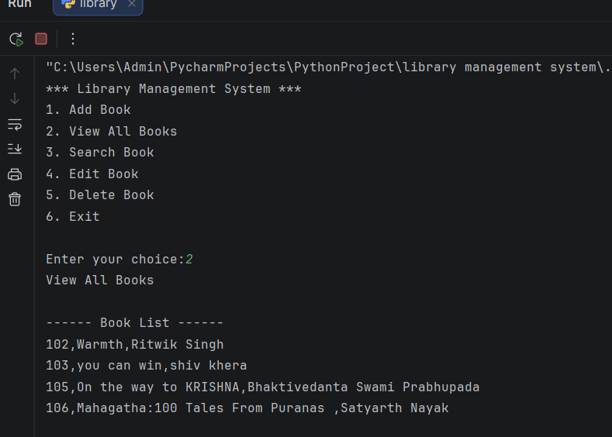

- Search Book
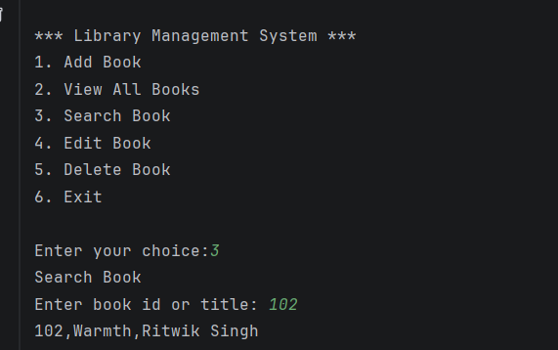

- Edit Book
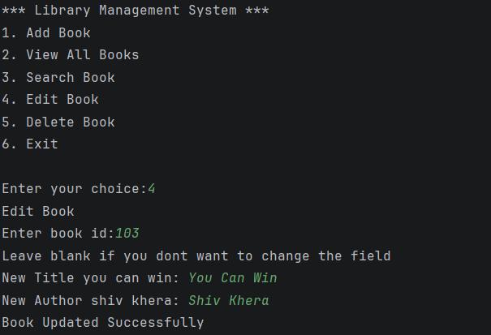
- Delete Book

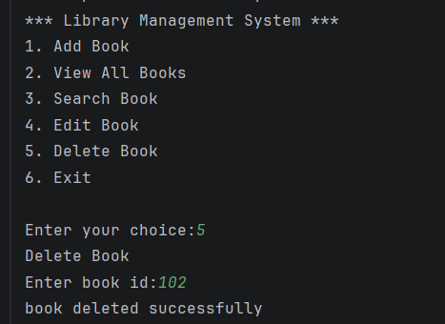

- Exit
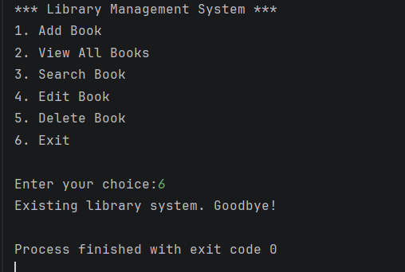

Scope of the Project
The scope of this Library Management System is to manage basic book records efficiently.
It allows users to add, view, search, edit, and delete book details easily. The system stores data permanently using file handling in a text file. This project is suitable for small libraries and for learning Python OOP concepts.
Conclusion
The Library Management System is a useful Python application for managing book records easily. It performs basic operations such as add, search, update, and delete using file handling. This project is helpful for learning Python OOP and real-life data management.

Thank You !!

